# specific signals in data for GW150914
from pycbc.catalog import Merger
from pylab import*
from pycbc.filter import resample_to_delta_t, highpass
merger = Merger("GW150914")
strain = merger.strain('H1')
strain = resample_to_delta_t(highpass(strain, 15.0), 1.0/2048)
plot(strain.sample_times, strain)
xlabel('Time (s)')
show()

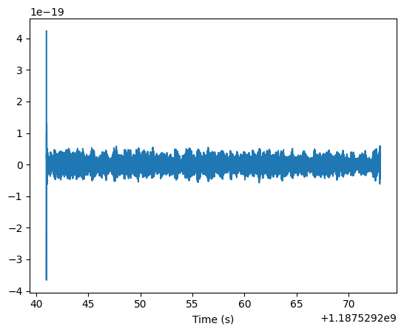

# filter wapour around

# Remove 2 seconds of data from both the beginning and end

conditioned = strain.crop(2, 2)
plot(conditioned.sample_times, conditioned)
xlabel('Time (s)')
show()

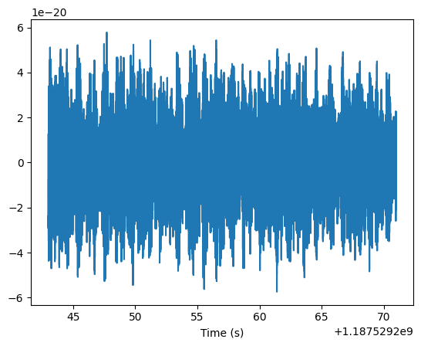

#power spectral density

from pycbc.psd import interpolate, inverse_spectrum_truncation
psd = conditioned.psd(4)
psd = interpolate(psd, conditioned.delta_f)
psd = inverse_spectrum_truncation(psd, int(4 * conditioned.sample_rate),
low_frequency_cutoff=15)
loglog(psd.sample_frequencies, psd)
ylabel('$Strain^2 / Hz$')
xlabel('Frequency (Hz)')
xlim(30, 1024)

# signal model
template = hp.cyclic_time_shift(hp.start_time)
plot(template)
show()
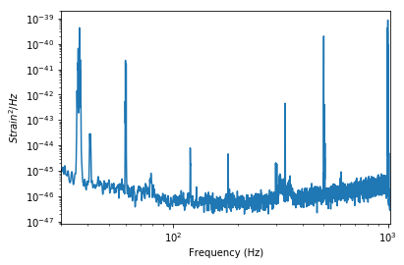

m = 36
hp, hc = get_td_waveform(approximant="SEOBNRv4_opt",
mass1=m,
mass2=m,
delta_t=conditioned.delta_t,
f_lower=20)

hp.resize(len(conditioned))

# snr to time

from pycbc.filter import matched_filter
import numpy

snr = matched_filter(template, conditioned,
psd=psd, low_frequency_cutoff=20)

snr = snr.crop(4 + 4, 4)
figure(figsize=[10, 4])
plot(snr.sample_times, abs(snr))
ylabel('Signal-to-noise')
xlabel('Time (s)')
show()

peak = abs(snr).numpy().argmax()
snrp = snr[peak]
time = snr.sample_times[peak]

print("We found a signal at {}s with SNR {}".format(time,
abs(snrp)))

